The Wireframe are drawn by online tools(https://app.diagrams.net/) and then take screenshot to Office Word, please contact [hutang@cn.ibm.com](mailto:hutang@cn.ibm.com) if you need original materials.

1. Sign in, if no account, click “Sign up” like to navigate to Sign up page.

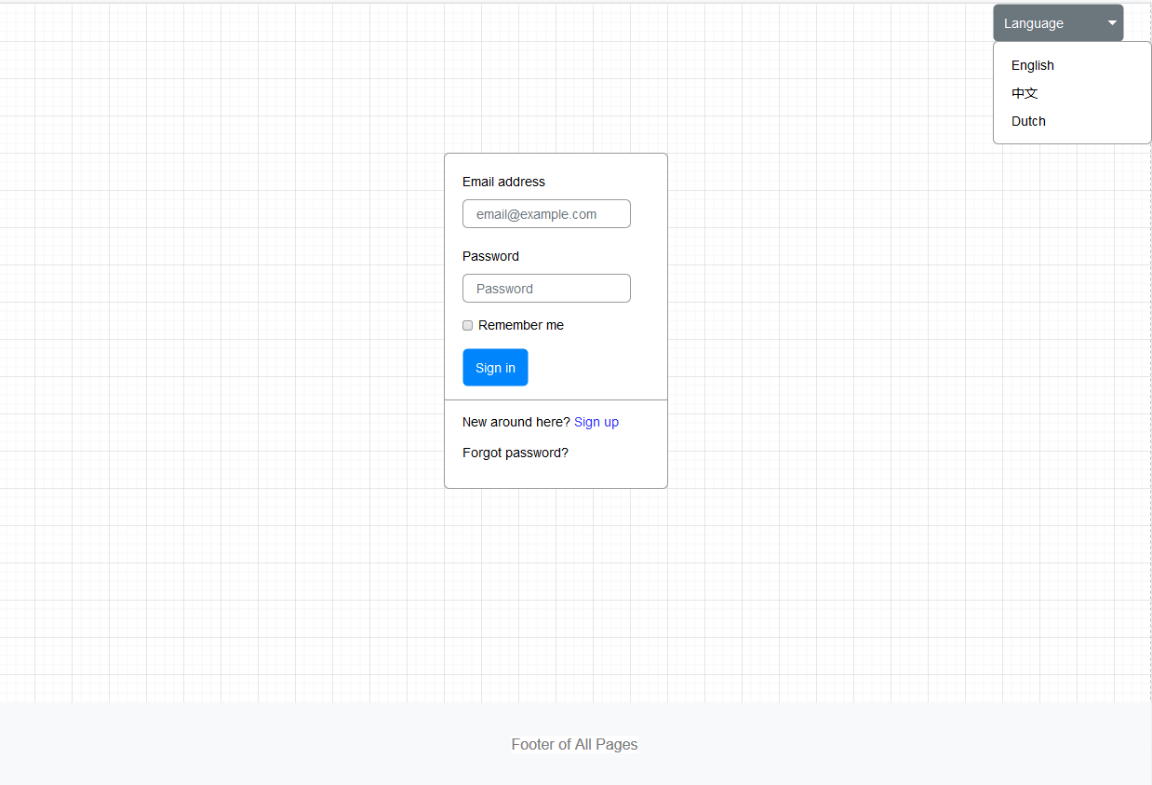

1. Sign up for Buyer(if Role = Seller, input for Company name, GSTIN, brief about company, Postal Address, website will display). if have account, click “Sign in” like to navigate to Sign in page.

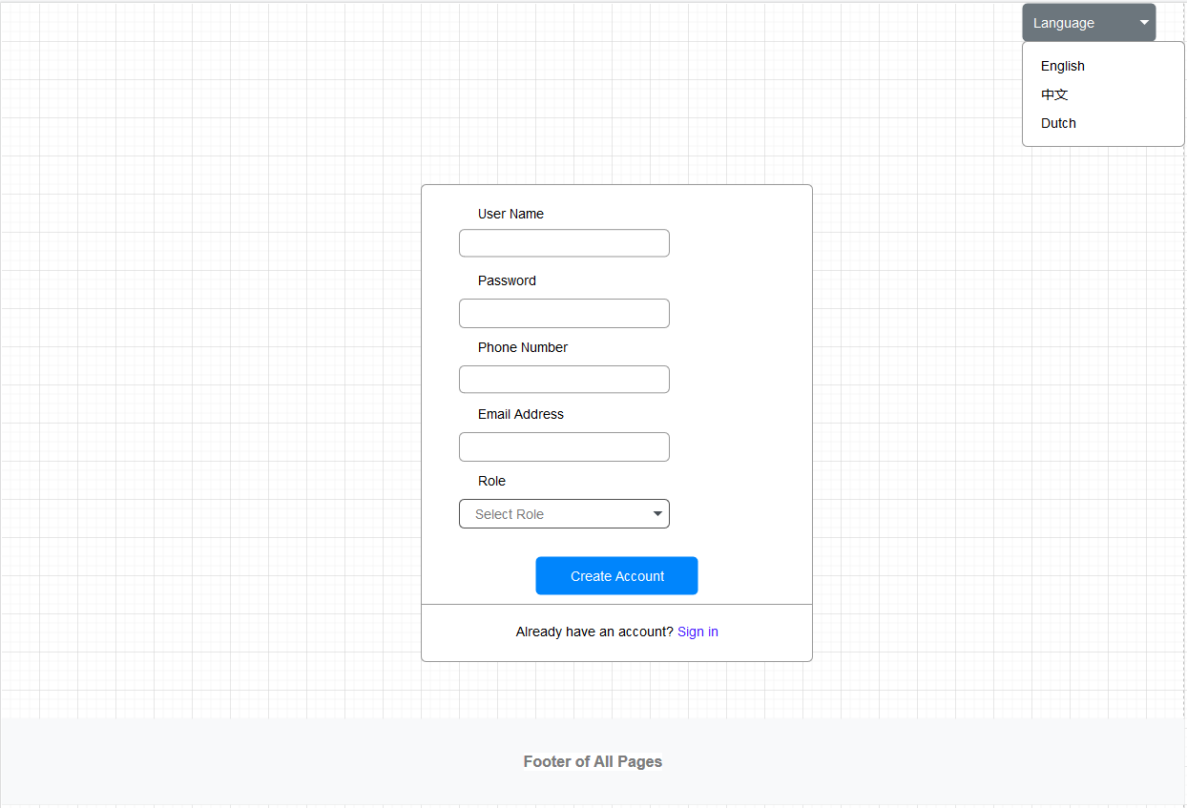

1. Buyer Page Design
2. Main Page after Sign in

Click the Image/Item/Short Description will navigate to detail of Item. Click “Shopping Cart”( ) in the Item will add it into cart.

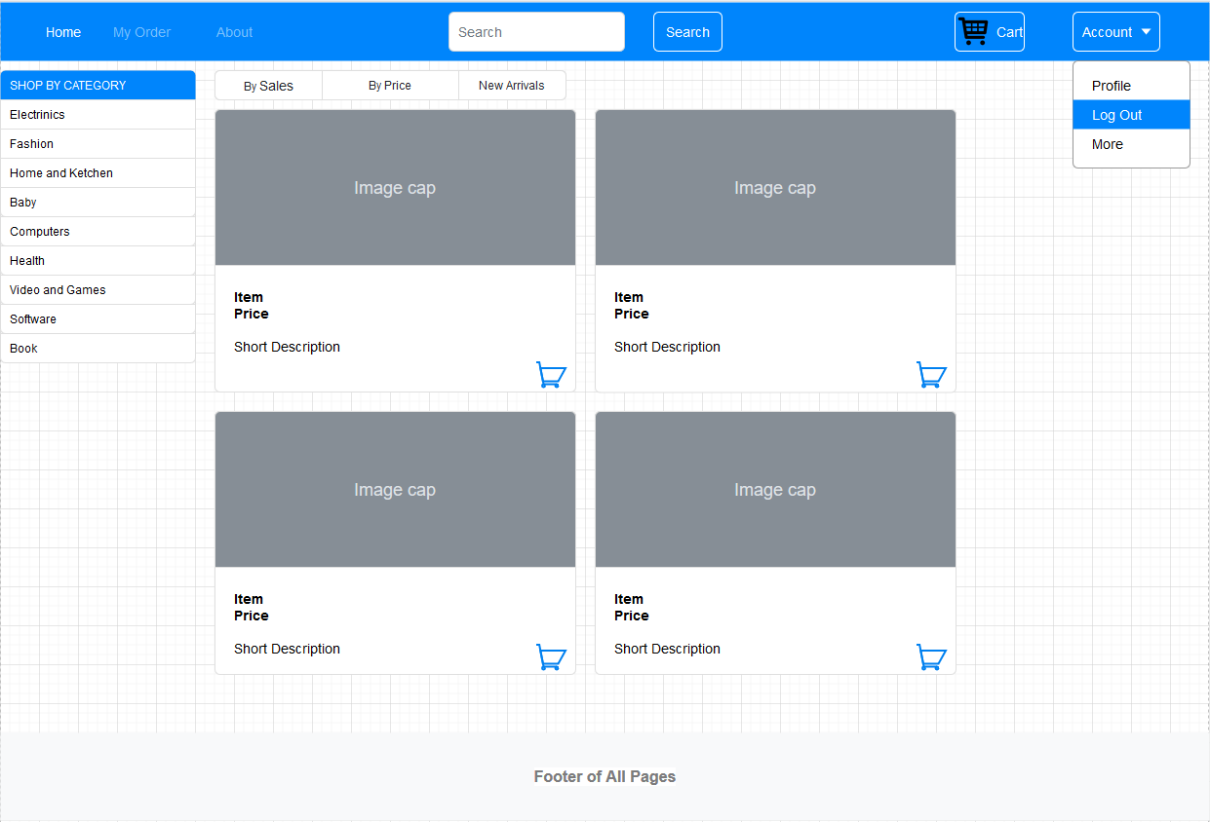

1. Item Detail Page

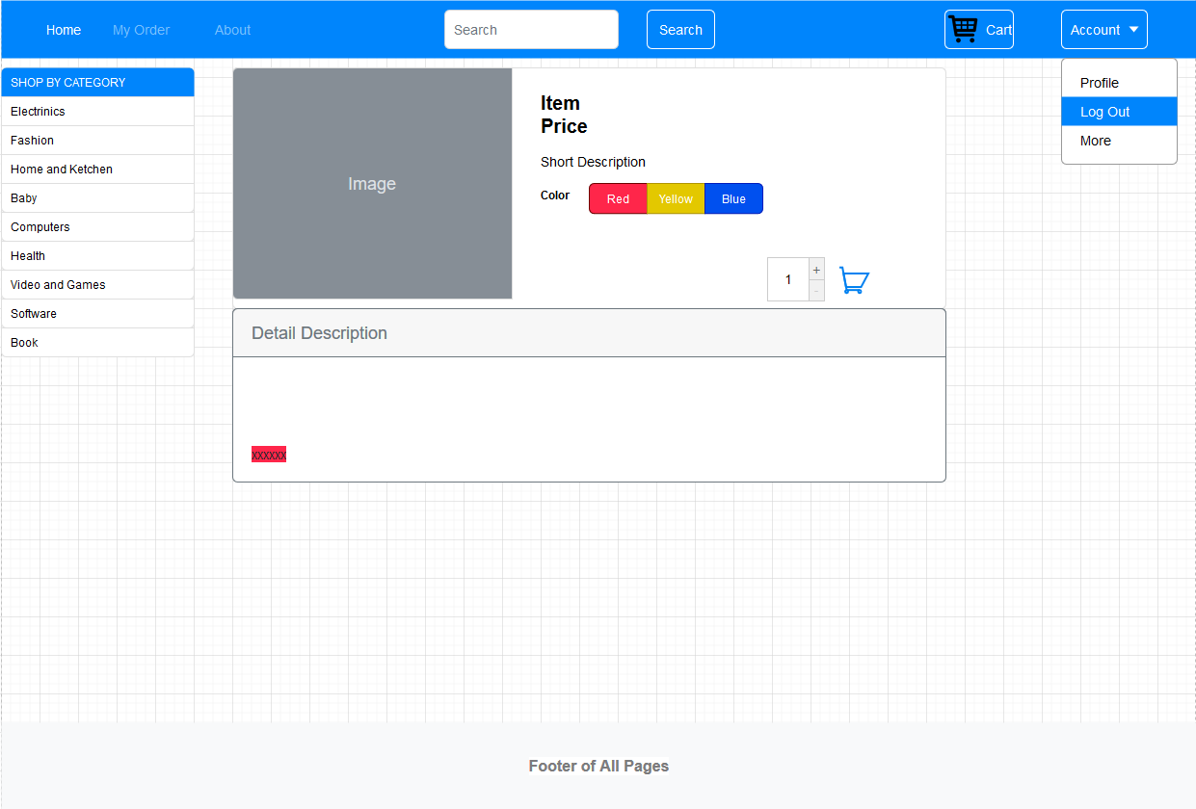

1. Shopping Cart

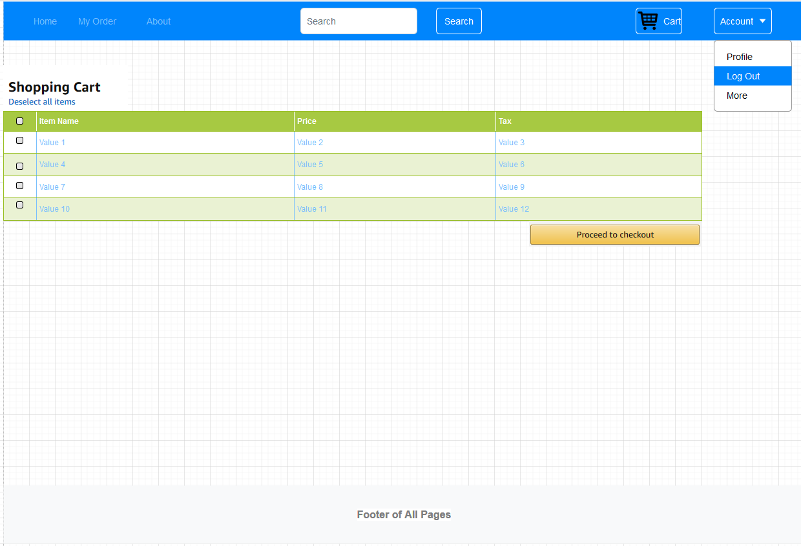

1. Order List

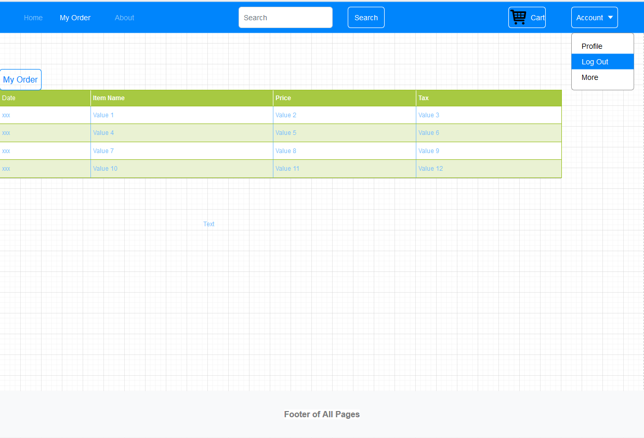

1. Seller Page Design
2. Home Page after Sign in

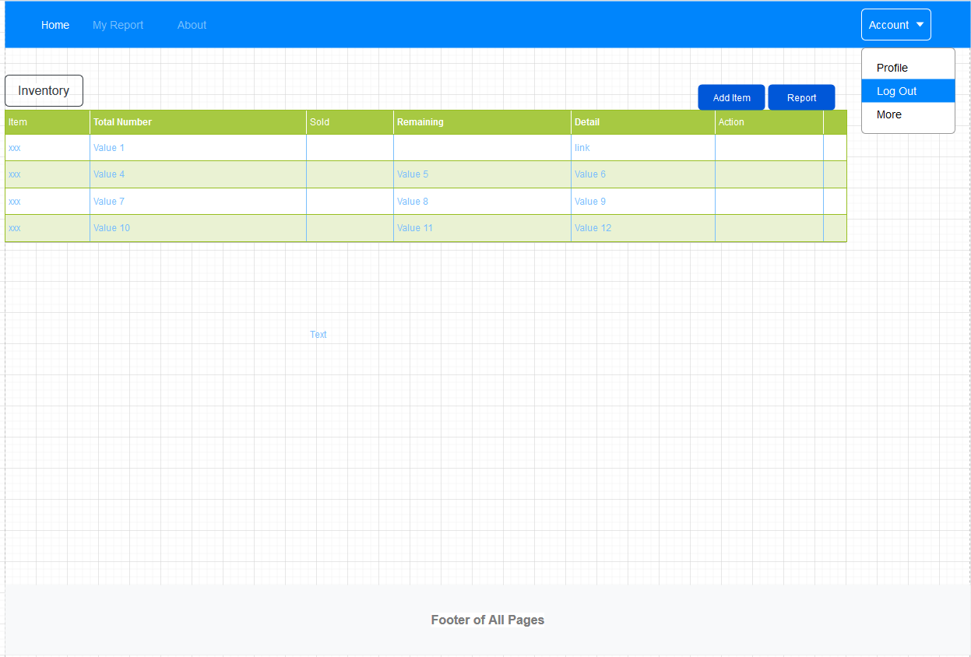

1. Add Item

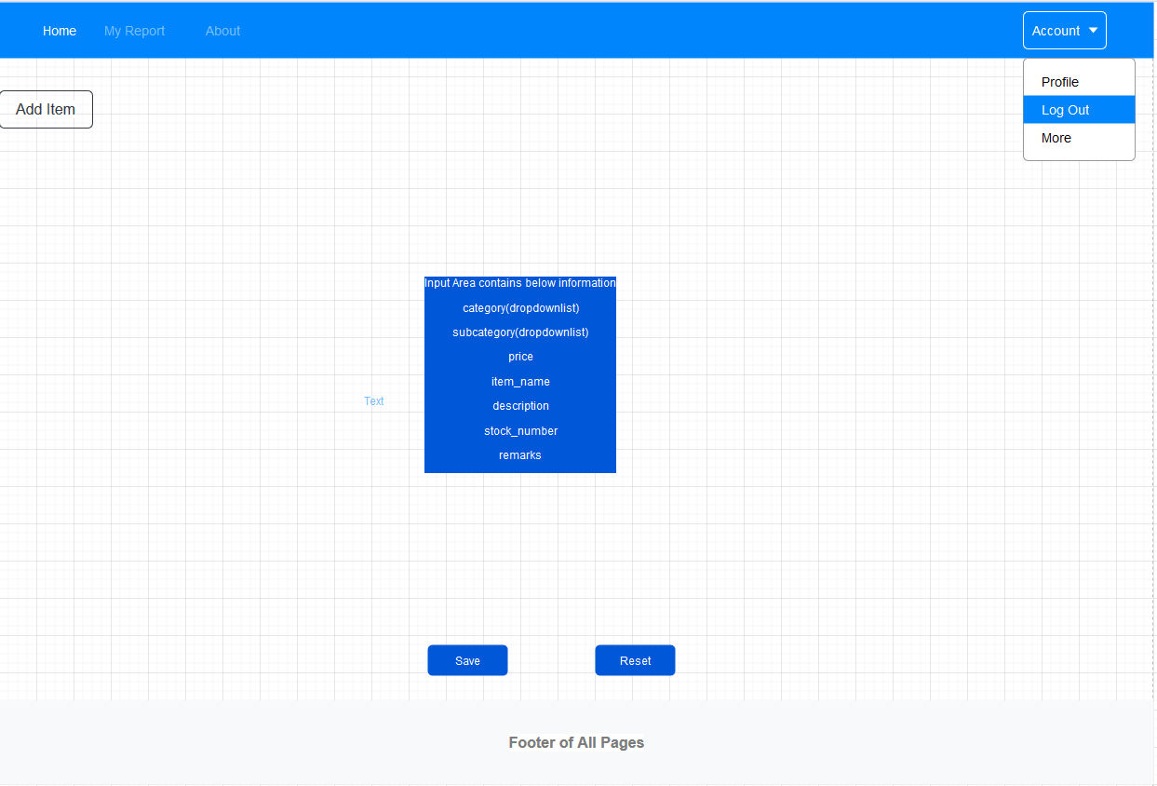

1. Report

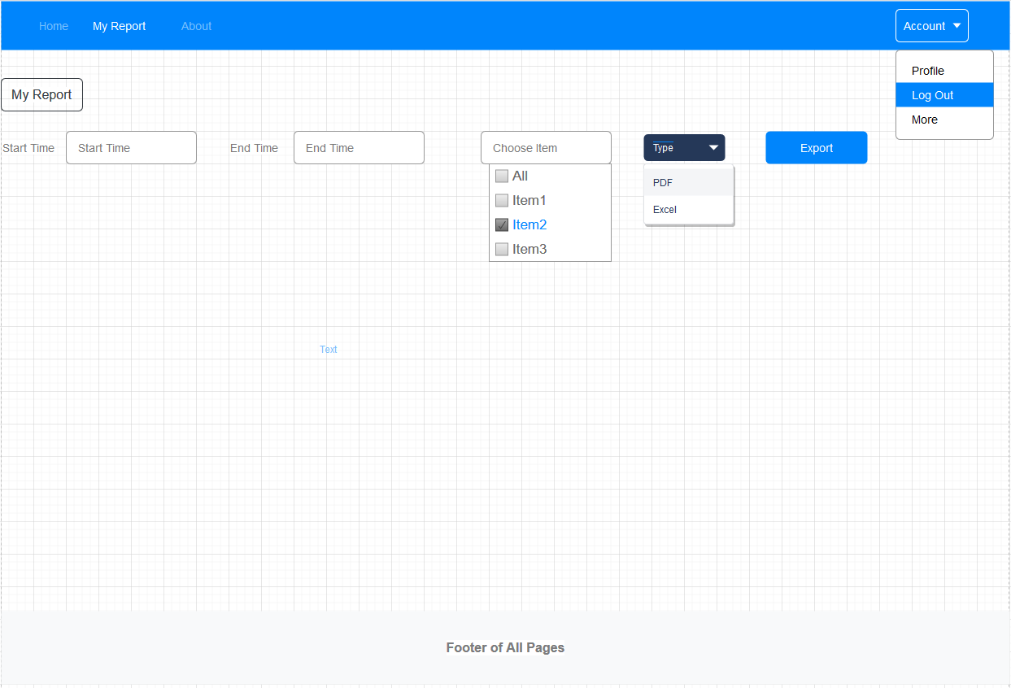

1. Admin Page Design
2. Home Page, show “Daily Turnover Category Wise”. Maybe some charts.

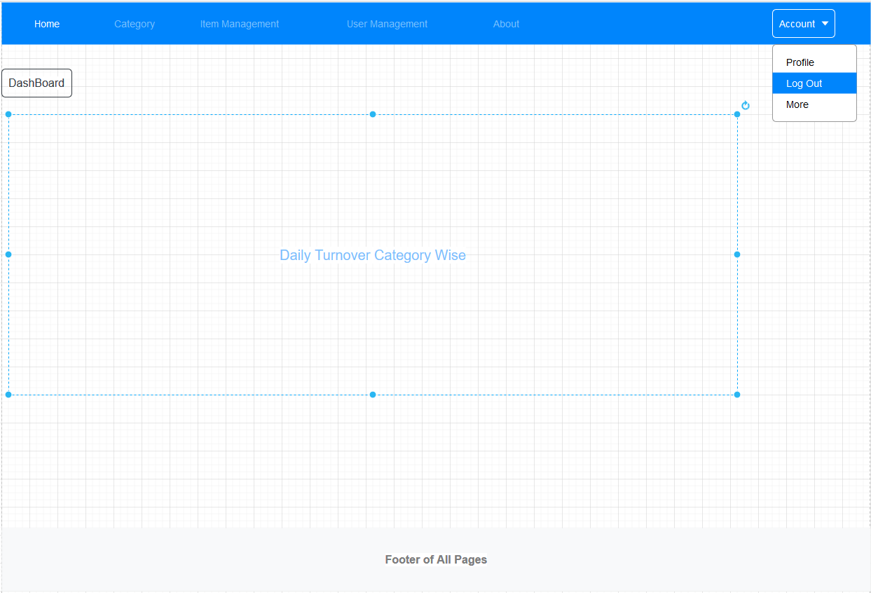

1. Category Management. Click “Add” button will navigate to Add Category page(Not draw). In Action column, can delete/edit Category(Not draw).

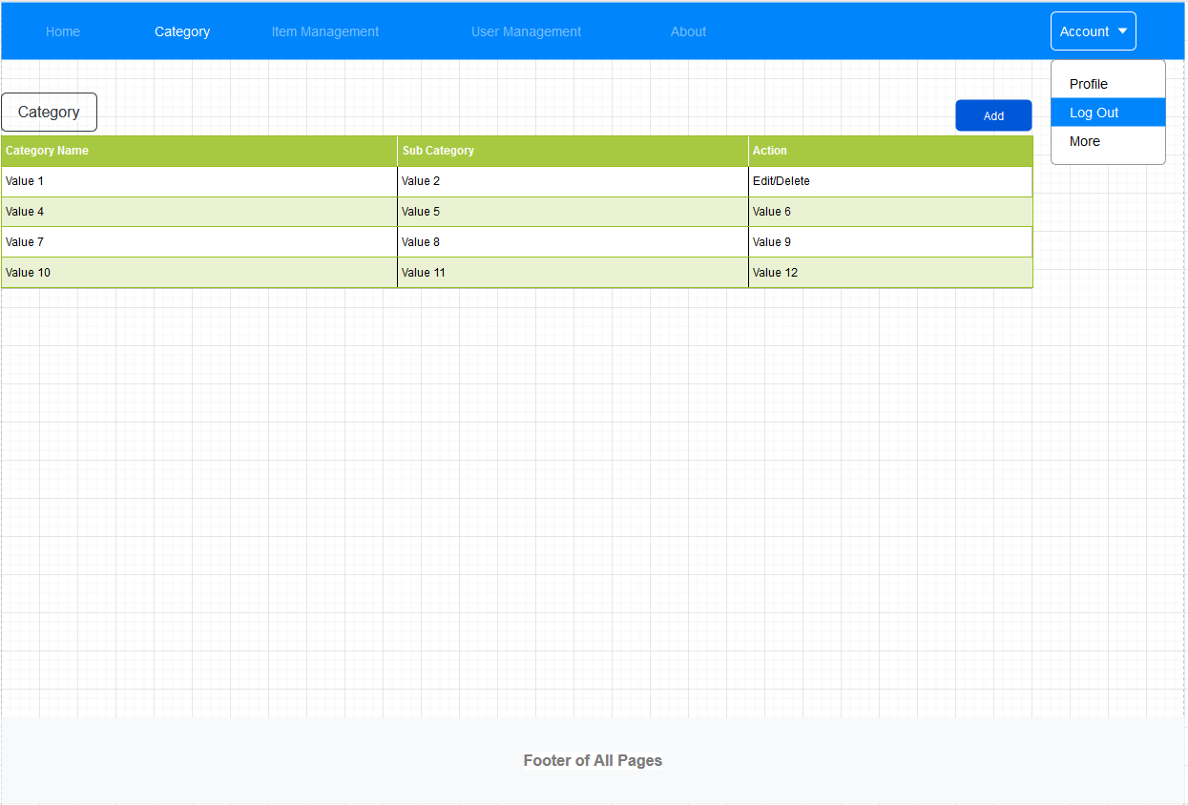

1. Item Management. Admin can Lock the time and set “Discount”(Popup a window to set code/start time/end time/) of this Item.

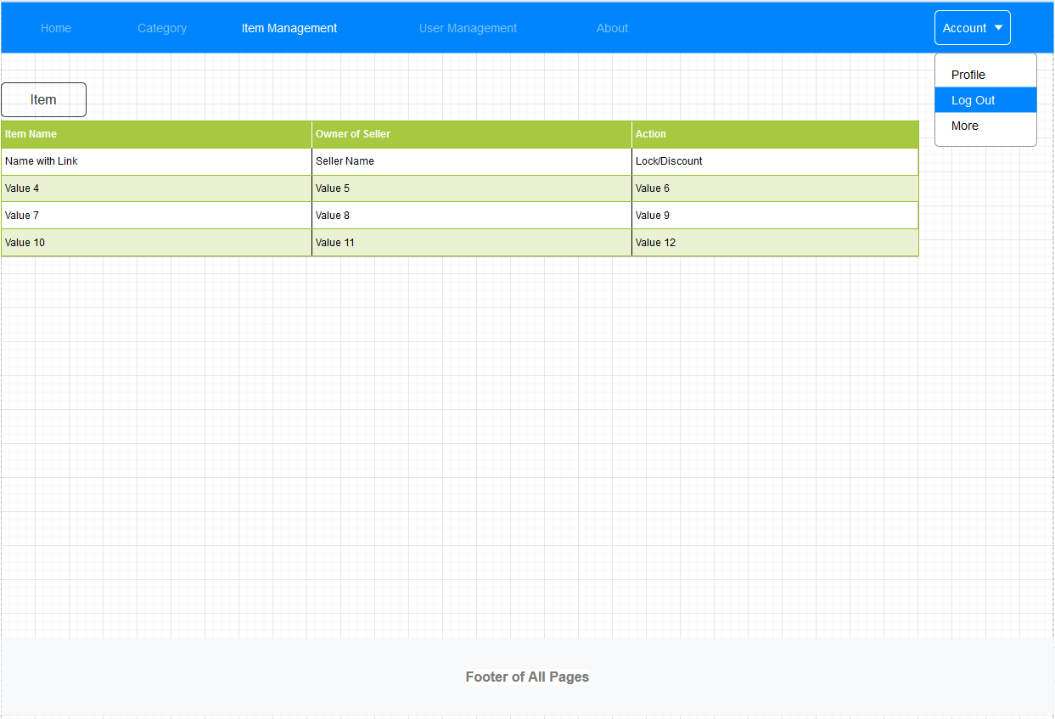

1. User Management.

